**Lord, You are more precious than silver**

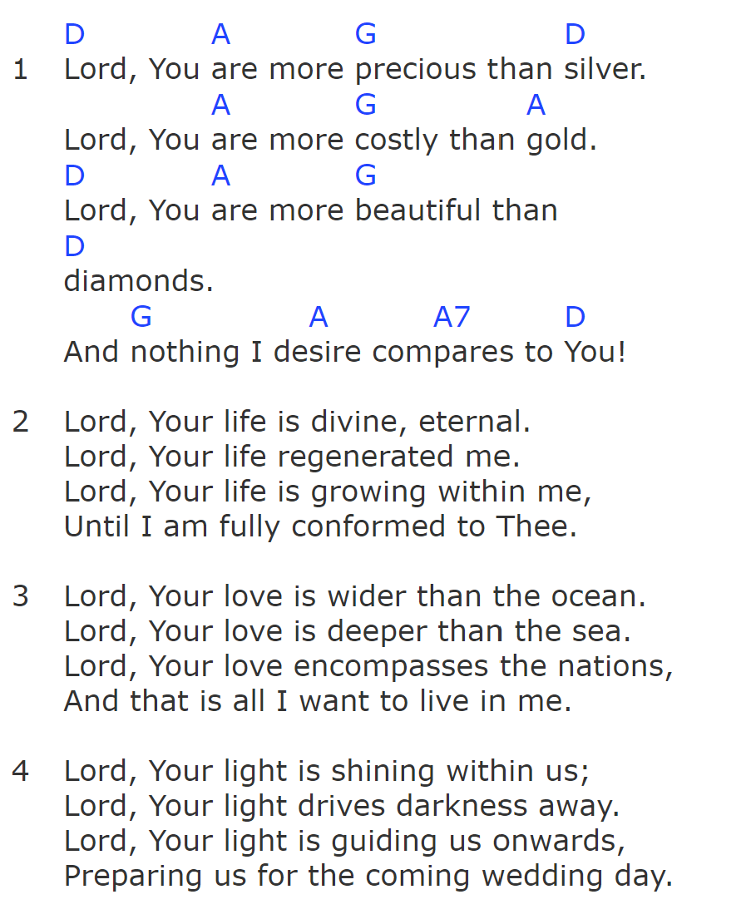

**Make me a channel of blessing**

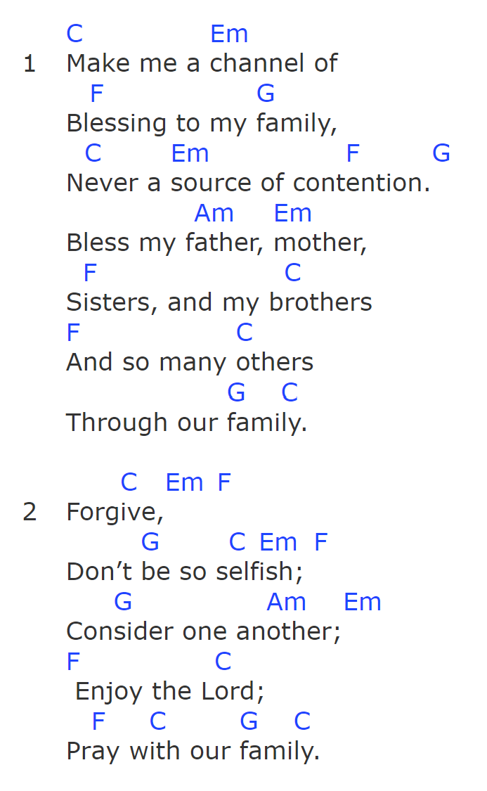

**Jesus Can Do Anything**

*Guitar: Capo 1, A major*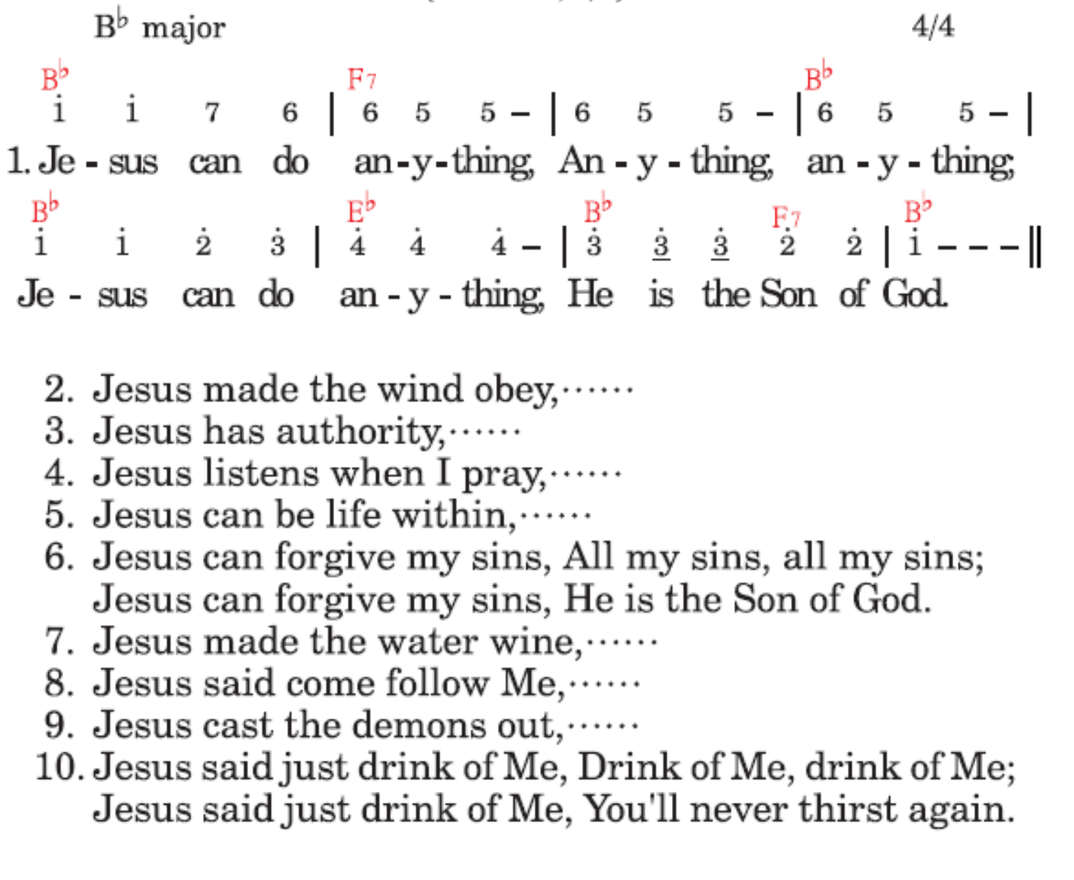





**Thou Will Show Me the Path of Life (Psalm 16:11)**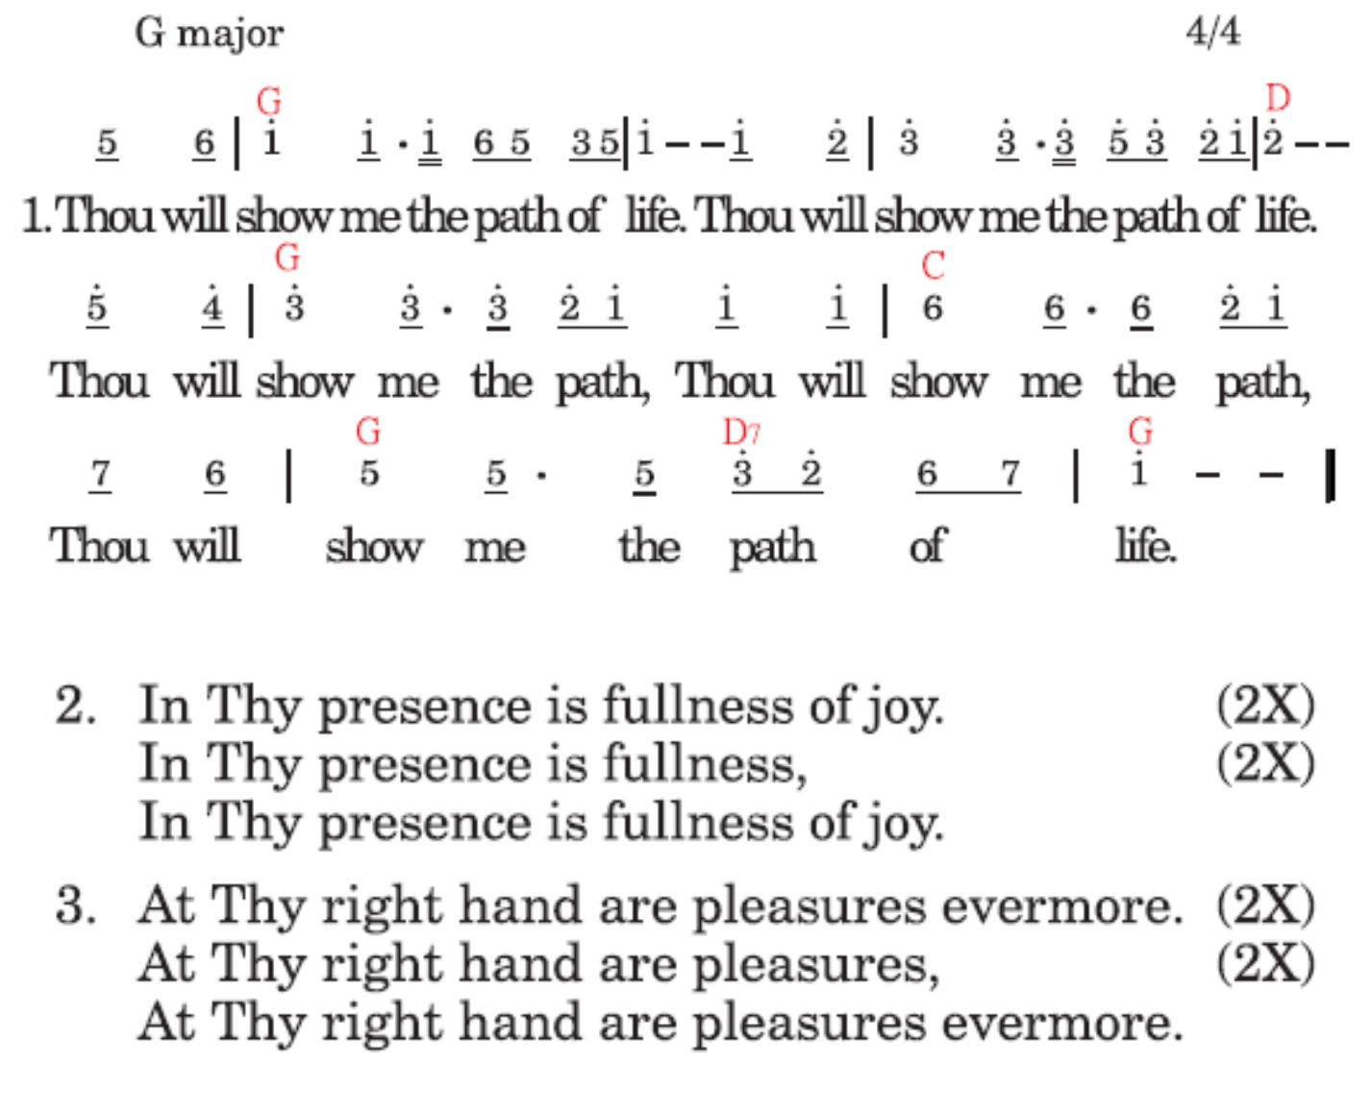

**The Joy of the Lord is My Strength (Nehemiah 8:10)**

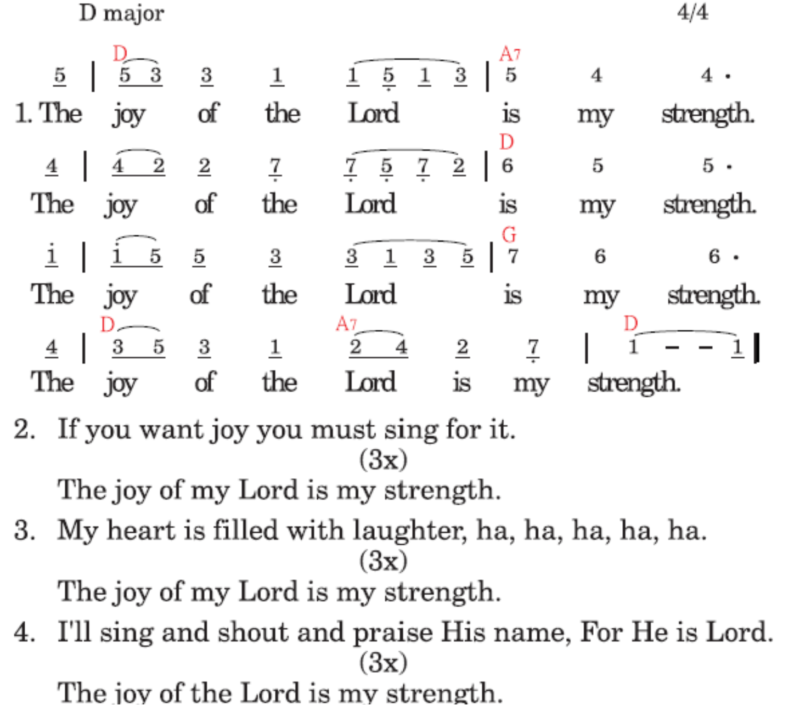

**Deuteronomy 30:19-20**

**Dm A Dm Bb-A**

I call heaven and earth to witness against you today,

**Dm A Dm Bb A**

I’ve set before you Life and death, blessing and curse.

**Gm F Dm C**

Therefore choose Life that you and your seed may live.

**F Gm Dm C**

Therefore choose Life that you may live, you and your seed.

**F Gm Dm**

Therefore choose Life that you may live.

The way for you to choose Life is to love the Lord your God,

By list’ning to His voice and holding fast unto Him.

For He is your Life and the length of all your days.

So choose Life by loving the Lord God, all of your days.

So choose Life by loving the Lord God.

**Take Twelve Stones Out**

**D G A**

Take twelve stones out, for a memorial.

**D G A**

Take twelve stones out, one stone for every tribe.

**D G A**

Take twelve stones out, then shall your children know.

**D G Em A D**

Israel came over Jordan marching on dry land.

What do these stones mean? Israel had chosen God.

What do these stones mean? A new life they’d begun.

What do these stones mean? That they would not turn back.

They’re God’s testimony living in the promised land.

**G D**

When the priest’s feet touched the river Jordan,

**Bm A**

The waters were blocked from a way off.

**G D**

And the riverbed was dry that the people,

**Em A A7**

Could pass over on dry land.

Put twelve stones in, for a memorial.

Put twelve stones in, to stay in Jordan’s flow.

Put twelve stones in, old life had passed away.

No more life of wandering, we have entered the good land.

When the priest’s feet touched the river Jordan,

The waters were blocked from a way off.

And the riverbed was dried that the people,

Could pass over on dry land

Take twelve stones out, for a memorial.

Take twelve stones out, one stone for every tribe.

Take twelve stones out, then shall your children know.

Israel came over Jordan marching on dry land.

**7 Priests, 7 Trumpets, 7 Times**

Chorus:

**D A** 

7 Priests, 7 Trumpets,

**A7 D**

7 Days, 7 Times.

**G Em D Bm**

Around the wall of Jericho,

**Em A D**

On the 7th day.



Jehovah was with Israel,

Because they listened and chose God.

And obeyed his plan to utterly defeat,

And capture Jericho.



(Chorus)

Even though it sounded kind of funny,

To walk around the city for six days.

Israel obeyed God’s instructions and way,

Concerning Jericho.

(Chorus)

On the seventh day they encompassed,

The entire city seven times.

Seven trumpets blew, and they shouted a great shout,

Then the walls came a`tumblin down.

2x (Chorus)

**Giving Song**

**G**

Joshua 7 tells a story ‘bout a man who’s name: Achan

**C G**

How he stole some gold and silver and then hid it in his tent.

**Em**

It belonged in the Lord’s treasury, but he kept it for himself.

**Am D7 G**

This cause defeated Ai.

**G**

Hiding, hiding, Achan’s hiding.

**C G**

Hiding, hiding, Achan’s hiding.

**Em**

Money that was for the treasury,

**Am D7 G**

For God’s Kingdom on the Earth.

I don’t want to be like Achan, I choose to give to the Lord

Week by week I’d offer back to Him from what he’s given me.

Say a little here, a little there, today and evermore.

I am not one who robs God.

Giving, giving, we are giving.

Giving, giving, we are giving.

Hallelujah, we are giving,

For God’s Kingdom on the Earth.

**You Can’t Always Trust What You See**

**D A**

You can’t always trust what you see.

**A7 D**

You might end up being deceived.

**G Em D Bm**

If Israel got fooled, then how about you?

**Em A D**

You can’t always trust what you see.

The Gibeonites were disguised.

That took Israel by surprise.

Much trouble occurred, not seeking the Lord.

But acting according to sight.

Things aren’t always as they appear.

So turn to the Lord, He’s so near.

His Word is your light, walk by faith not sight.

Things aren’t always as they appear.

**Choose God - Choose Life**

**D**

Choose God, choose God

Choose to stay whom you will serve.

**A**

Choose God, choose God

But it's for me and my house.

**D**

Choose God, choose God

We will serve Jehovah.

**A**

Choose God, choose God

**D A G D**

Choose to stay whom you will serve.

Choose Life, choose Life

I set before you life and death.

Choose Life, choose Life

Therefore choose Life that you may live.

Choose Life, choose Life

Listening and holding fast to Him.

Choose Life, choose Life

He is your Life and length of days.

**Be Strong and of Good Courage**

Chorus:

**D A**

Be strong and of good courage

**A D**

Do not be afraid, neither be dismayed

**G D**

For Jehovah, your God, is with you

**G A7 D**

Wherever you go

(Chorus again)

**D A**

After Israel has wandered in the wilderness

**D**

For a period of 40 years

**G D**

It was time for the younger generation

**E E7 A**

To fight for the promised land

Now the Lord had already chosen Joshua

`Cause he took the lead to choose God

As he stood on the border of the good land

God gave him this command:

(Chorus)

Now as younger ones living for God’s purpose

In the midst of God’s enemies I'm

Be encouraged to take a stand to choose God

He will be your victory



(Chorus)

**Do you know that you were chosen**

**D A**

Do you know that you were chosen

**Bm F#m**

Long before the world began

**G D**

That by God you were selected

**Em A**

And appointed for His plan

**D A**

What a mercy to be chosen

**Bm F#m**

In this aim to have a part

**G D**

To be one with Christ that we may

**Em A D**

Satisfy God’s very heart.

**God Has Chosen Us**

(To Tune of Jesus Won’t You Come)

Capo 3

**D G**

God has chosen us, we will answer and obey

**D A**

We will choose to take God’s way

**D G**

God has chosen us, we will answer and obey

**D A D**

We will choose to take God’s way

**D G**

We choose to obey, follow what our parents say

**D A**

We’ll take this first step, until one day

**D G**

We choose to obey, and to take our parents’ way

**D A D**

Stand for God and His purpose each day

**D G D A**

We believe all that God has promised He will carry out.

**D G D A D**

We receive all the blessing; when we let go, God works it out.

**Honor and Obey**

*Chorus*:

**D G D A**

God’s plan has placed me in my family

**D G D A**

He made my parents the authority

**D A**

To care for me

**D A**

Meet all my needs

**D G**

I will obey

Following directions

**D G**

I will honor

Respect and highly value

**D**

God has

**Bm A A7**

placed my own parents over me

**D**

Honor and obey

*Chorus*:   
God’s plan has placed me in my family / He made my parents the authority

To care for me / Meet all my needs

If I obey

God, in His Word, has told me

If I honor

That my days will be long.

I will

enjoy all God has promised me.

Honor and obey

*Chorus:*

God’s plan has placed me in my family / He made my parents the authority

To care for me / Meet all my needs

**D A A7 D**

Today I choose… to honor and obey

**The Bible is God’s Word.**

(Capo 2)

**G C-Cmaj7-Am7**

The Bible is God’s Word.

**D G Bm-Em**

I hide it in my heart

**Am Am7 D**

It is a lamp to my feet

**G B7 Em**

And also a light to my path

**C-Cmaj7-Am7**

Guiding me on my way

**D G-B7 Em**

To bring me safely to life

**Am-Am7-D**

Shining more brightly ‘til

**D7 G-C-G**

The dawning of day

I open up God’s Word

And on His Word set my heart Through it God speaks to me His Word’s the food that I eat Nourishing me deep within Strengthening me not to sin His Word dwelling richly is The joy of my heart

Thank you, Lord, for Your Word Thank you, You gave it to me Help me to read everyday And practice to pray as I read That means I talk with You Letting Your Word shine in me Warming, preparing me For Your Word to grow

**We Know, We Know**

**E**

We know, we know (We know, we know)

**A**

That we have passed (That we have passed)

**E**

Out of death (Out of death)

**B**

And into life (And into life)

**E**

Because we love (Because we love)

**A**

We love the brothers (We love the brothers)

**E**   **B**

We know we passed from death to life

**B7 E**

Because we love the brothers

**I have an Excuse!**

**D Bm A D**

I have an excuse to praise my God and Father,

**Bm Em A**

I have an excuse to give thanks to my Lord.

**D Bm A Bm**

I have an excuse to give glory to my God,

**G D A7 D**

Because I know that He is and He’s on the throne.

**D7 G D**

Praise the Lord! Praise the Lord!

**A D**

I will bless the God and Father

**G D**

Praise the Lord! Praise the Lord!

**E A**

Of my Lord Jesus Christ

**G D**

Praise the Lord! Praise the Lord!

**A Bm**

I will praise while I have breath

**G D A D G D**

Because I know that He is and I have breath now.

I have an excuse to praise my God and Father,

I have an excuse to give thanks tomy Lord.

I have an excuse to give glory to m y God,

Because I know that He is and He’s on the throne. Hallelujah!

Praise You God and Father!

Hallelujah!

Praise You Lord Jesus Christ!

Hallelujah!

I will praise while I have breath

Because I know that He is and He loves me so.

**I Belong to You**

(Capo 2)

(Chorus)

**G C D G**

Lord Jesus, I belong to You

**C**

You chose me long ago

**D G**

And You’re helping me to grow

**C**

I may not know You

**D G**

But You really want me to

**C**

I give myself to You

**D G**

I want to be with You

**C D**

Lord, I want to serve You

**G**

When I grow up

**C D**

So teach me how to pray

**G**

And call on You

**C D G**

And read my Bible everyday

**C D G**

Help me to hear Your voice always

**C D**

And I’ll be in the church

**G**

With all the saints

(Chorus)

**God Speaks the Truth**

**Am5 Am3 Am5-Am3**

God speaks the truth; He cannot tell a lie.

**Am5 Am3 Am5-Am3**

His words are faithful, trustworthy and true.

**D E A**

He won’t forget His promises to You.

**D E A-Am3**

He will fulfill all that He said He’d do.

**43**

**Speak to me, Lord every day**

**D G D**

Speak to me, Lord every day.

**D G D**

Speak to me, Lord –I love to hear what you say.

**D G D**

Speak to me, Lord until I have heard.

**Em D G-A D-G-D**

Speak to me, Lord through Your living Word.

Speak to me, Lord every day.

Speak to me, Lord –I love to hear what you say.

Speak to me, fill me with light.

Speak to me, Lord all Your words of life.